CS-114 - Fundamental of Programing

Lab # 8

**Course Instructor:** Dr Khwaja Fahad Iqbal

**Lab Instructor:** Muhammad Affan

## Student Name: Muhammad Hanzla Masood

**CMS ID: 463722**

**Task 1:**

#include <bits/stdc++.h>

using namespace std;

int main(){

int a[10], b[10]={0};

bool check=false;

cout<<"Input 10 integers: \n";

for(int i=0; i<10; i++){

cin>>a[i];

}

for(int j=0; j<10; j++){

for(int i=1; i<10; i++){

if(a[j]==a[i]){

b[j]++;

}

}

}

for(int i=9; i>=0; i--){

for(int j=0; j<10; j++){

if(b[j]==i){

cout<<"The most repeated number is "<<a[j]

<<" coming "<<b[j]+1<<" times in the array. ";

check=true;

break;

}

}

if(check==true){

break;

}

}

return 0;

}

**Task 1 Output:**

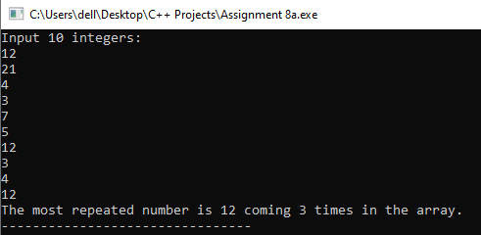

**Task 2:**

#include <bits/stdc++.h>

using namespace std;

int main(){

int a[8]={13,15,17,9,99,77,65,43},

smallest=0, largest=0;

for (int i=1; i<8; i++){

if (a[i]<a[smallest]){

smallest=i;

}

}

for (int i=1; i<8; i++){

if (a[i]>a[largest]){

largest=i;

}

}

cout<<"Smallest Integer: "<<a[smallest]<<endl

<<"Largest Integer: "<<a[largest];

return 0;

}

**Task 2 Output:**

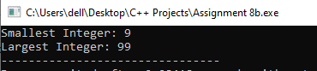

**Task 3:**

#include <bits/stdc++.h>

using namespace std;

int main(){

int a[5], temp;

cout<<"Input 5 integers: \n";

for(int i=0; i<5; i++){

cin>>a[i];

}

temp=a[2];

a[2]=a[4];

a[4]=temp;

cout<<"The integeres with position 3 and 5 swapped are: \n";

for(int i=0; i<5; i++){

cout<<a[i]<<endl;

}

return 0;

}

**Task 3 Output:**

